**Installation**

Git Bash is included with the 'Git For Windows' package. Download the latest version of the Git Bash package from the official website and install it just like the other Windows applications. Following is the link to download 'Git for Windows':

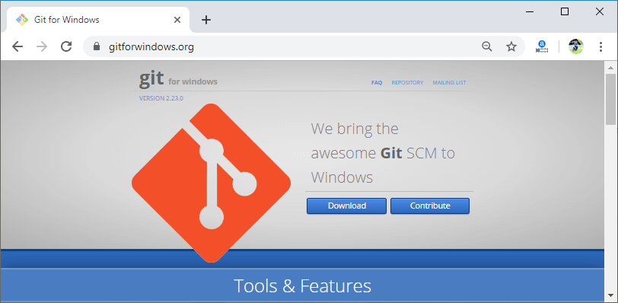

Once the package is downloaded, run the executable file:

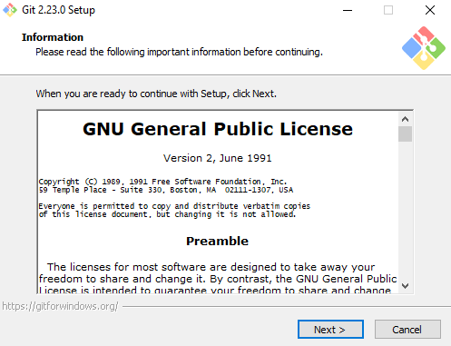

Choose the valid path where you want to install the Git Bash:

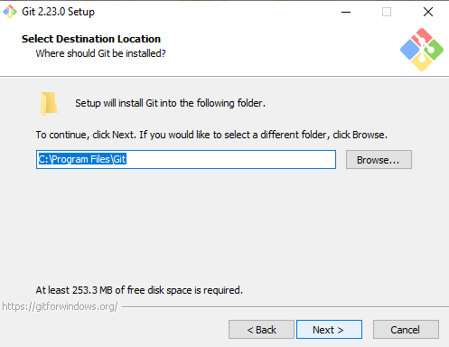

Select the appropriate componenets you want to install and hit 'next' button:

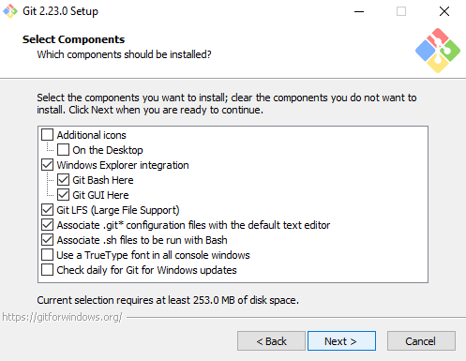

Follow the next on screen instructions to finish the installation.

To check the version of Git for Windows, use the command:

1. git --version

After running this command, the output will look like this:

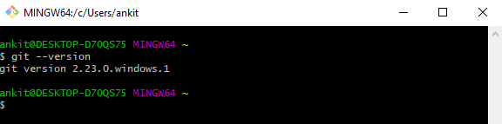

Launch Git Bash

After the installation is completed, search for the icon named 'Git Bash' and double click on it to start the Git Bash. It will start a 'bash shell' integrated with Git.

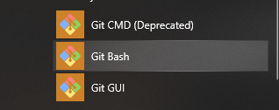

Git Bash works as similar as a standard bash and is useful to review basic Bash usage. It includes the complete set of Git core commands. It is also packaged with additional commands which can be found in the /usr/bin directory of the Git Bash emulation.